1. By looking at the above figure, the 48 bit ethernet address of my computer is 00:d0:59:a9:3d:68

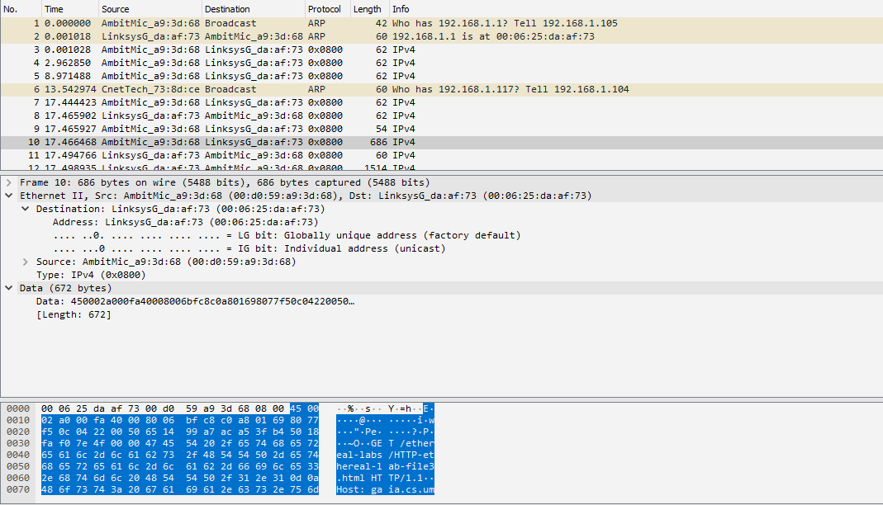

1. The destination address is 00:06:25:da:af:73. This address is not the Ethernet address of gaia.cs.umass.edu, but it is the address of my linksyg link router (reference: screenshot from question 1)
2. According to the screenshot from question 1, the hexadecimal value for the frame type field is Type: IPv4 (0x0800). It is an IP protocol.
3. According to the screenshot from question 1, there are exactly 54 bytes from the very start of the Ethernet frame does the ASCII “G” in “GET” appear in the Ethernet frame?
4. According to the screenshot, the ethernet source address is 00:d0:59:a9:3d:68. This address is not the address of my computer or gaia.cs.umass.edu. This is the address of Ambitmic router.

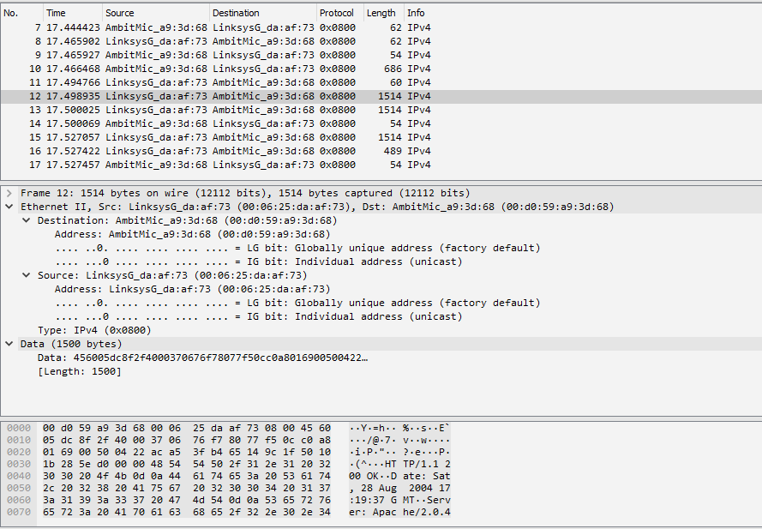

1. The destination ethernet address is 00:d0:59:a9:3d:68. Which is the address of AmbitMic router
2. According to the screenshot in question 5, the hex value of this field is 0x0800. It corresponds to the IPv4 protocol.
3. According to the screenshot in question6, the O in OK appear 52 bytes in the Ethernet frame.

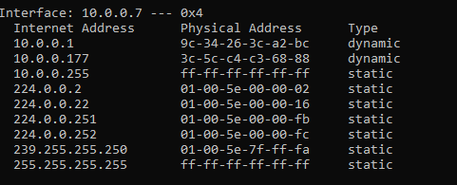

Internet Address: IP address

Physical Address: the MAC address

Type: The protocol type

1. According to the screenshot, the hexadecimal value for the source is 00:d0:59:a9:3d:68, and for destination it is ff:ff:ff:ff:ff:ff

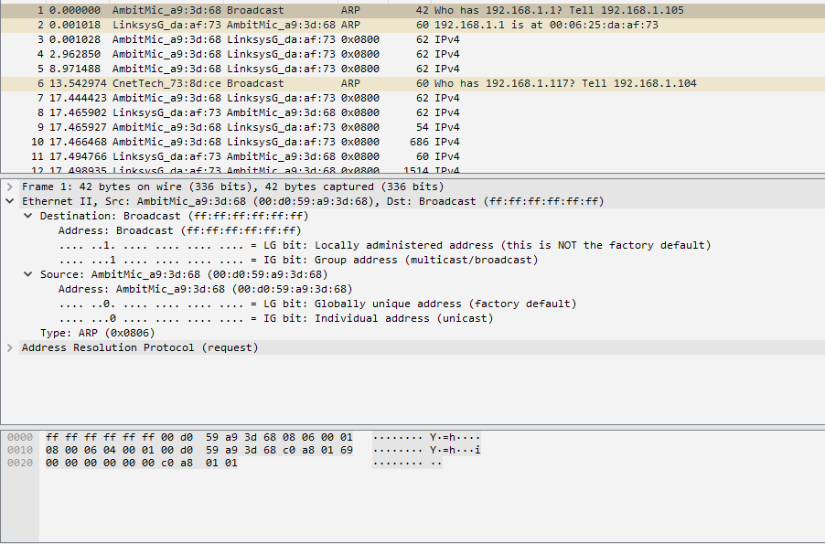

1. The hex value for the two byte Ethernet frame is 0x0806, the corresponding upper layer protocol is ARP.

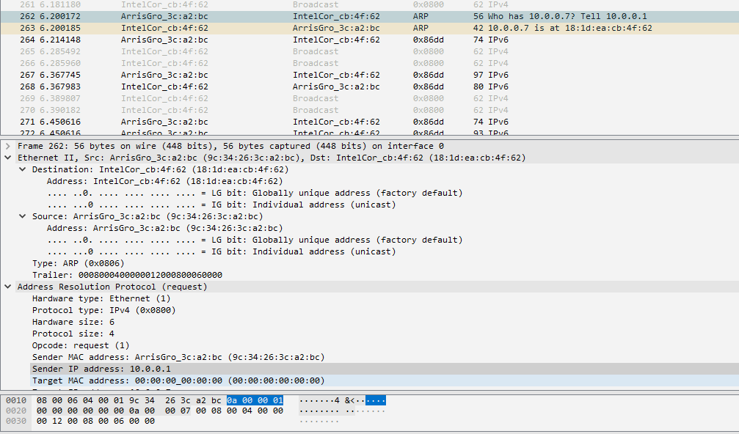

1. 20 bytes
2. 0x0001
3. Yes. The sender ip address is: 10.0.0.7
4. The Target MAC address is 00:00:00:00:00:00, this broadcast will queries the machine which IP address is 10.0.0.7.

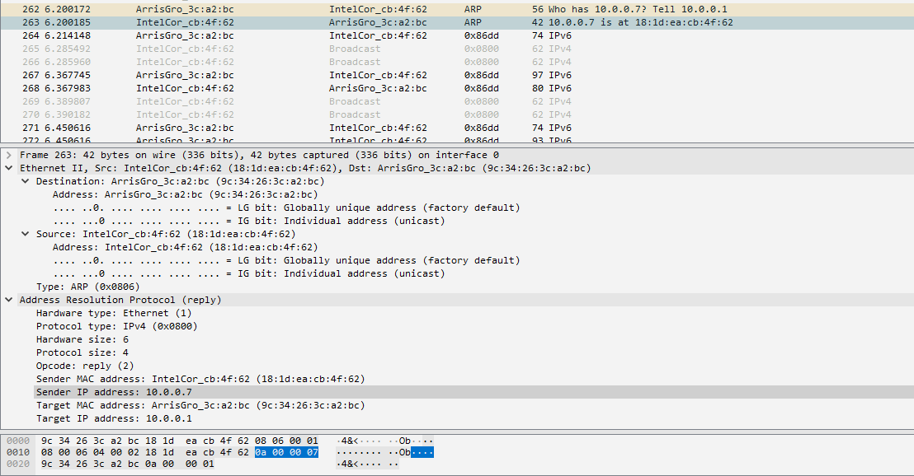

1. 20 bytes
2. 0x0002
3. Sender IP address: 10.0.0.7 and Sender MAC address: 18:1d:ea:cb:4f:62 does the “answer” to the earlier ARP request.
4. Referring to the screenshot in question 13, Destination ip: 9c:34:26:3c:a2:bc Source ip: 18:1d:ea:cb:4f:62
5. Because the ARP request is broadcast, but the ARP reply is not broadcast. The reply will be sent to the computer who made the request directly.